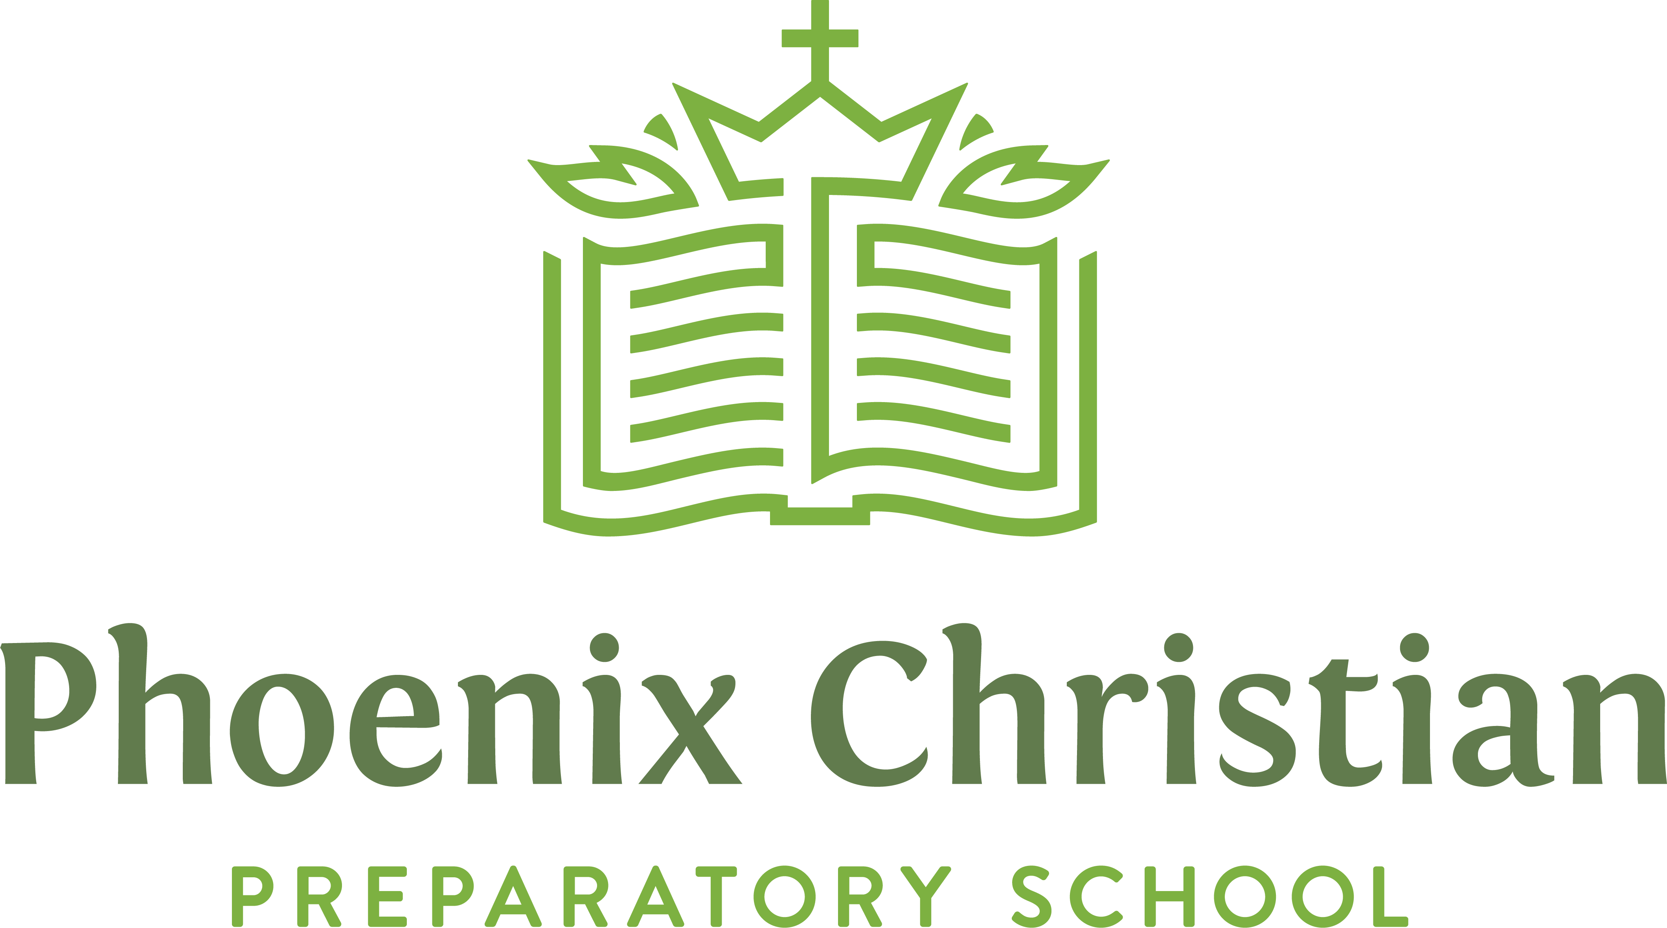

Instructional Student Support Aide
Job Description

The Instructional Support Aide collaborates with classroom teachers and works with students individually and in small groups to help students be successful learners. The qualified individual must be an evangelical Christian committed to living a Biblical lifestyle. He/she is expected to demonstrate patience, humility, integrity, and kindness while performing his or her day-to-day duties. He/she must be devoted to prayerfully work with administration, faculty, students, and parents to develop and maintain a school that is thoroughly Christian and academically superb. The Aide reports to the R.I.S.E.N. (Responding to Individual Student’s Educational Needs).

Personal Qualifications
  - Be deeply committed to a consistent daily walk with Jesus Christ.
  - Spend time daily in personal devotions and prayer.
  - Show in his/her life the joy of the Christian life.
  - Follow the Matthew 18 Principle in dealing with students, faculty, parents, and administration.
  - Motivate students to accept God's gift of salvation and to grow in their faith.
  - Possess the ability to work gracefully with parents, students, and other school staff to develop a unified and successful educational program.
  - Demonstrate the ability to accept and carry out responsibilities and make competent, professional decisions.
  - Be willing to eagerly participate in professional development.
  - Recognize the role of parents as primarily responsible before God for their children's education and be prepared to assist them in that task
  - Maintain a personal appearance that is a Christian role model of cleanliness, modesty, good taste, and in agreement with school policy.
  - Possess a teachable attitude and desire to work collaboratively.
  - Respectfully submit and be loyal to constituted authority. Shall notify the administration of any policy he/she is unable to support.

Qualifications
- Continuing education credits from an accredited college or university preferred
- Experience working with children with special needs desirable

Essential Duties and Responsibilities

- Act as an instructional aide for students with diverse needs and learning differences.
- Work closely with classroom teachers to support the educational needs of the student.
- Work with students individually and in small groups providing academic support both in and out of the classroom setting.
- Be able to use a wide variety of academic strategies to support students in the classroom setting.
- Assist with record-keeping procedures to document student learning and performance.
- Collaborate with a team to ensure students get the support they need to achieve academic and personal success at school.
- Maintain regular contact with parents to foster effective and participatory parent involvement in the student’s education.
- Prepare various teaching aids and materials such as charts, graphs, and other related items using such methods as typing, duplicating, collating, stapling, and laminating.
- Administer, monitor, and supervise exams and assessments.
- Participate in any meetings necessary (before, during, or after school) to support the student’s success.
- Demonstrate a willingness to work collaboratively as an educational team member.
- Abide by all state and federal mandates in reporting sexual or physical abuse and neglect.
- Perform any other related duties as assigned.

Hours
20 – 25 hours per week

